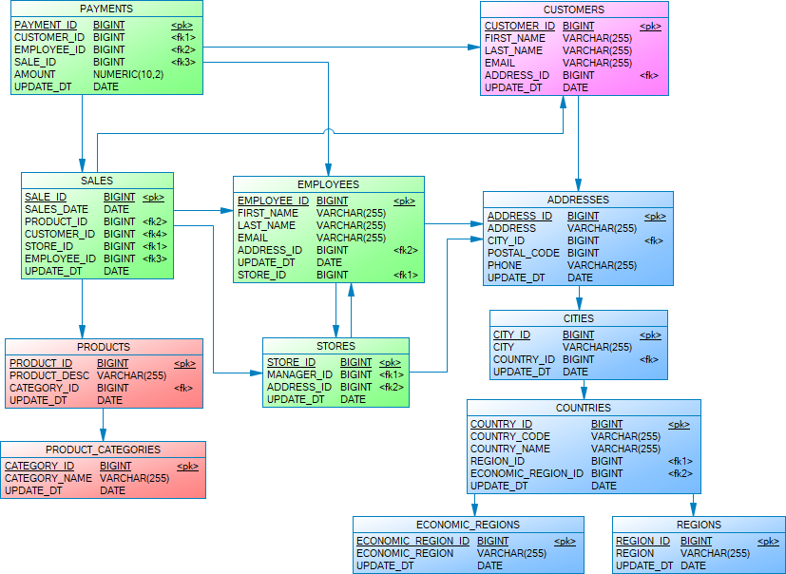

Creating a star schema
We begin with a normalized database schema, where information is stored across many related tables to avoid duplication. In our case, we had a structure where: Sales data is recorded in the SALES table. Information about customers, employees, stores, products, and locations is stored across several other tables like CUSTOMERS, EMPLOYEES, PRODUCTS, CATEGORIES, ADDRESSES, CITIES, COUNTRIES, etc.
To convert this schema to a star schema I followed these steps:
Step 1: Picked the Fact Table
The SALES table is chosen as the main fact table because it records key events — each sale, its amount, and when/where it happened.
Step 2: Chose Dimension Tables
I selected the following tables to describe the sales: CUSTOMERS, PRODUCTS, EMPLOYEES, STORES, DATE .
Step 3: Combined Related Information
To make reporting easier, I combined related tables into single, flat tables. For example:
- In the CUSTOMERS table, we added details from ADDRESSES, CITIES, COUNTRIES, and REGIONS.
- In the PRODUCTS table, we added the product category name directly.
Step 4: Connected All to the Fact Table
We linked all the dimension tables directly to the SALES table. The result looks like a star, with SALES in the center and dimensions around it — this is why it's called a star schema.

Result:
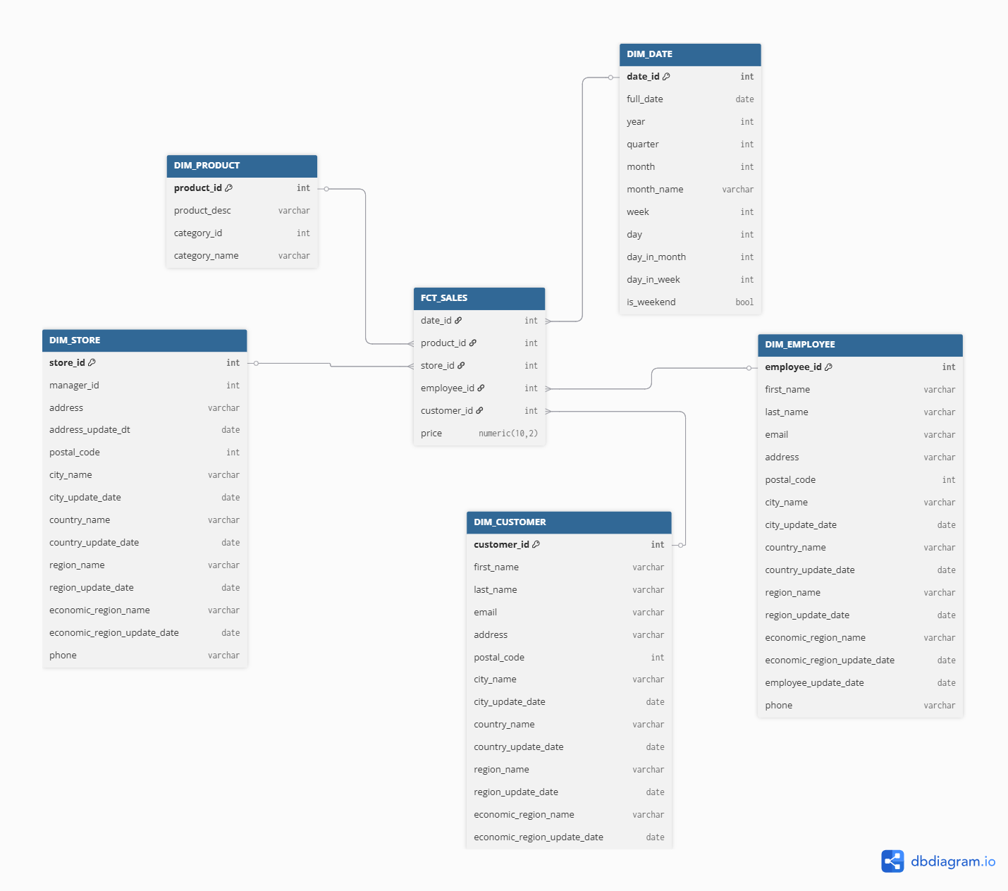

Transforming the star schema to a snowflake:
The star schema is simple and good for performance, but it can lead to data repetition. To avoid this, we can convert it into a snowflake schema by breaking large dimension tables into smaller related ones again. For the result I did the following:
Step 1: Identified redundant attribute groups and hierarchies
From the denormalized Star Schema, we spot repeating groups and hierarchies:
Product Category appears in every product row
Address, City, Country, Region, Economic Region repeat across DIM_CUSTOMER, DIM_EMPLOYEE, DIM_STORE
Price is duplicated per transaction but may change over time (needs SCD)

Step 2: Normalized product dimension
I broke out Product Category into a separate dimension:
DIM_PRODUCT now references DIM_CATEGORY via category_id.

Step 3: Normalize price using type 2 SCD
I move price from FCT_SALES into a separate SCD-managed dimension:
Added start_date, end_date, is_active for version tracking.
FCT_SALES now references price_id, not product_id.

Step 4: Normalized address and geography hierarchy
Break down full geographic info into multiple normalized tables:
From Star Dimensions | To Snowflake Hierarchy
address, postal_code | DIM_ADDRESS
city_name | DIM_CITY
country_name | DIM_COUNTRY
region_name | DIM_REGION
economic_region_name | DIM_ECONOMIC_REGION
DIM_ADDRESS references DIM_CITY
DIM_CITY → DIM_COUNTRY → DIM_REGION → DIM_ECONOMIC_REGION
DIM_CUSTOMER, DIM_EMPLOYEE, and DIM_STORE reference DIM_ADDRESS
Step 5: Updated fact table
I replaced foreign keys to flattened dimensions with links to the lowest-level normalized versions:

Result:
